Abstract style for XII-ICQC 2006

E. Schrödinger, P. A. M. Dirac and W. Heisenberg
Department of Synthetic Chemistry & Biological Chemistry
Graduate School of Engineering, Kyoto University
Katsura, Nishikyou-ku, Kyoto 615-8510, Japan

I. International Congress of Quantum Chemistry
The XIIth International Congress of Quantum Chemistry (XII-ICQC2006) will be held at Kyoto, May 21-26, 2006, organized under the auspices of the International Academy of Quantum Molecular Science. The congress site is Kyoto TERRSA [1], which is located south close to Kyoto Station.
The Congress is held every three years and brings together scientists from all over the world. The first one was arranged 1973 at Menton (the headquarter of the Academy). Further sites were New Orleans, Kyoto, Uppsala, Montreal, Jerusalem, Menton, Prague, Atlanta, Menton, and Bonn. Major goals of the Congress are to provide an overview of recent novel developments, advances and directions of research in the broad area of quantum molecular sciences as well as to establish interaction between the theoretical discipline of quantum molecular science and experiment. Topics to be discussed cover a broad range of fields, from the development of fundamental methodologies to applications in a wide area of chemistry, biochemistry, pharmacology and molecular and solid state physics.
II. Poster presentation
All contributed papers will be presented as posters. “Best Poster Award” of ICQC2006 will be given for the best posters through public votes of all attendants. A participant who wants to present a poster is requested to submit an abstract by March 31, 2006.

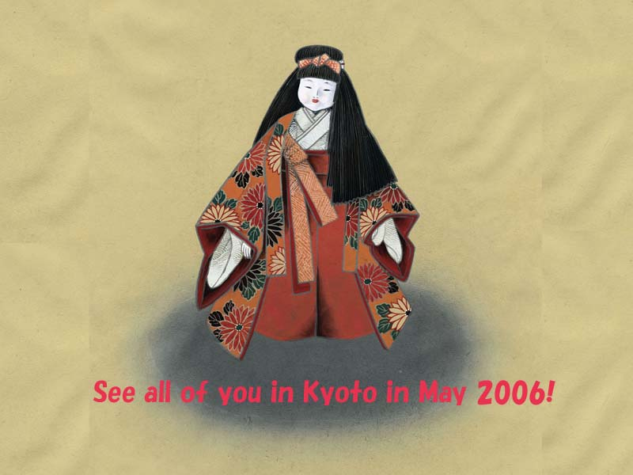
Table 1. ICQC Congress Sites since 1973.
Place | Year | Country
Kyoto | 2006 | Japan
Bonn | 2003 | Germany
Menton | 2000 | France
Atlanta | 1997 | USA
Prague | 1994 | Czechoslovakia
Menton | 1991 | France
Jerusalem | 1988 | Israel
Montreal | 1985 | Canada
Uppsala | 1982 | Sweden
Kyoto | 1979 | Japan
New Orleans | 1976 | USA
Menton | 1973 | France  Figure 1. Welcome to Kyoto. Color figures are printed in black-and-white in the book of abstracts.
The Congress is held every three years and brings
together scientists from all over the world.

[1] 15min. walk from JR Kyoto Station; 5 min. walk from subway station (Kujyo); 5 min. walk from Kintetsu Railway station (Toji).

