Supplementary material for
X-ray Photoelectron Spectroscopy of Thymine and 5-Bromouracil Studied
by Symmetry-Adapted-Cluster Configuration-Interaction (SAC-CI) Theory

Yusaku I. Kurokawa,^{1a} Hiroshi Nakatsuji^{1＊}, Misaki Hirato,² and Akinari Yokoya³

¹ Quantum Chemistry Research Institute, 16 The Kyoto Technoscience Center, 14 Yoshida Kawara-machi, Sakyo-Ku, Kyoto 606-8305, Japan
² Graduate School of Science and Engineering, Ibaraki University, Mito, Ibaraki 310-8512, Japan.
³ Institute for Quantum Life Science, National Institutes for Quantum Science and Technology, 2-4 Shirakata, Tokai, Ibaraki 319-1106, Japan.

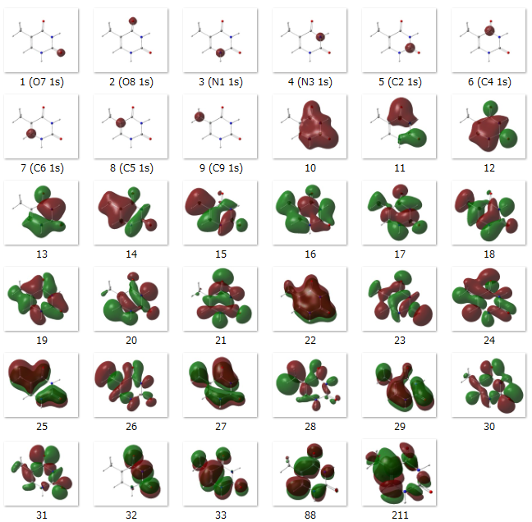
Figure S1. Occupied molecular orbitals (MOs 1 - 33) of Thymine (T), where the surface of the isovalue 0.02 is plotted, and unoccupied Rydberg orbitals (MOs 88 and 211) of Thymine (T), where the surface of the isovalue 0.01 is plotted.
The C6 1s and C5 1s ionizations are two-electron processes accompanied by the excitations from HOMO (MO 33) to the unoccupied Rydberg orbitals 88 and 211, respectively. See Table 1 text for details.

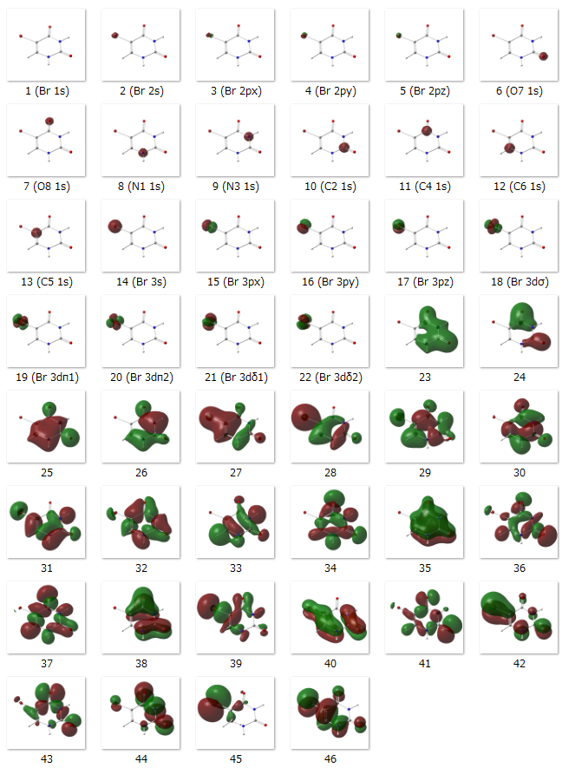
Figure S2. Occupied molecular orbitals (MOs 1 - 46) of 5-Bromouracil (BrU), where the surface of the isovalue 0.02 is plotted. No two-electron processes appeared in the main configuration of inner-core excitation of BrU.

